**The 15 Mysteries of the Rosary**

**The Five Joyful Mysteries (Monday & Thursday)**  
**I. The Annunciation**

1. 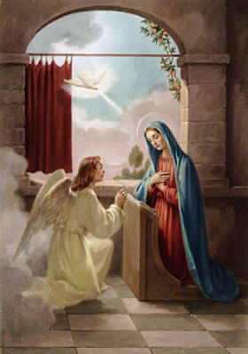The Angel Gabriel is sent to Nazareth.
2. The Angel greets Mary: “Hail, full of grace; the Lord is with thee.”
3. Mary is troubled at the Angel’s word.
4. Gabriel tells Mary that she is to be the Mother of God.
5. Mary speaks of her virginity: “How shall this be done, since I know not man?”
6. The Angel foretells the Virgin Birth.
7. Gabriel also says that Elizabeth has conceived a child in her old age.
8. Mary consents: “Behold the handmaid of the Lord; be it done unto me according to thy word.”
9. The Word is made flesh.
10. Mary adores the God Who has become incarnate within her womb.

**II. The Visitation**

1. Mary hastens to visit Elizabeth in her time 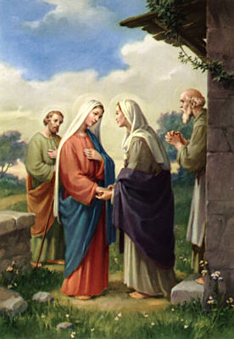of need.
2. Mary greets Elizabeth.
3. At the sound of Mary’s voice, John leaps for joy in his mother’s womb.
4. Elizabeth praises Mary: “Blessed art thou among women and blessed is the fruit of thy womb.”
5. Mary returns praise to God: “My soul doth magnify the Lord...”
6. Mary waits on Elizabeth.
7. John the Baptist is born, and the people celebrate.
8. Zachary’s tongue is loosed, and he praises God.
9. Joseph fears to take Mary for his spouse.
10. An Angel reassures Joseph, telling him that Mary has conceived by the Holy Ghost.

**2.**

**IV. The Assumption of the Blessed Virgin**

1. Mary longs to see her Son.
2. 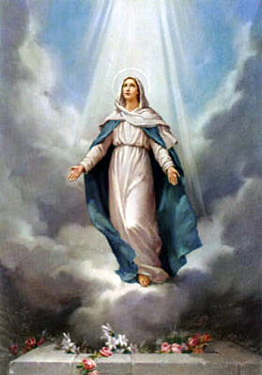Soon she is to be reunited with Him in Heaven.
3. The Apostles come to see Mary before she dies.
4. They are heartbroken that she is to leave them.
5. Mary consoles and strengthens each of the Apostles.
6. Her love for her Son is so great that her body can no longer contain her soul.
7. She dies in peace and great joy.
8. Mary is laid to rest.
9. Mary is assumed into Heaven and is received joyously in Heaven.
10. The Apostles find the tomb empty.

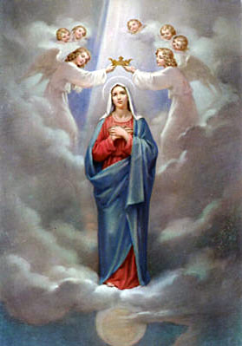**V. The Coronation of Our Blessed Mother**

1. Jesus crowns Mary Queen of Heaven.
2. She is enthroned at the right hand of Jesus.
3. Mary is seen crowned with twelve stars.
4. The Angels and Saints praise her.
5. The faithful on earth praise her.
6. Mary intercedes for us with her Son.
7. Jesus cannot refuse the prayers of His Holy Mother.
8. St. Joseph reigns with Jesus and Mary.
9. The day of Judgment approaches.
10. The Church longs for heaven.

**7.**

**SIGN OF THE CROSS: IN THE NAME OF THE FATHER AND OF THE SON**

**AND THE HOLY GHOST. AMEN (Matt. 28:19)**

**THE APOSTLES' CREED  
I BELIEVE IN GOD, the Father Almighty, Creator of Heaven and earth**

**And in Jesus Christ, His only Son, our Lord, who was conceived by the**

**Holy Ghost, born of the Virgin Mary, suffered under Pontius Pilate; was**

**crucified, died, and was buried. He descended into hell. The third day He rose again from the dead. He ascended into Heaven, and now sits at the right hand of God, the Father almighty, from thence He shall come to judge the living and the dead. I believe in the Holy Ghost, the holy Catholic Church, the communion of saints, the forgiveness of sins, the resurrection of the body, and life everlasting. (Words of the apostles)**

**OUR FATHER, who art in heaven, Hallowed be Thy Name.   
Thy Kingdom come, Thy Will be done, on earth as it is in Heaven.**

**Give us this day our daily bread. And forgive us of our trespasses, as we forgive those who trespass against us. And lead us not into temptation but deliver us from evil. Amen. (Matthew 6:9)**

**HAIL MARY full of Grace, The Lord is with thee. Blessed art thou among**

**women and blessed is the fruit of thy womb Jesus.**

**Holy Mary, Mother of God, pray for us sinners now and at the hour of our death. (Luke 1:28)**

**GLORY BE to the Father and to the Son and to the Holy Ghost. As it was in the beginning, is now, and ever shall be, world without end. (Matt.28:19)**

**OH, MY JESUS, forgive us our sins, and save us from the fires of Hell,**

**Lead all souls to Heaven, especially those most need of Thy mercy.**

**(In 1917 BVM in her apparition at Fatima included it in Rosary prayers)**

**HAIL HOLY QUEEN, Mother of mercy, our life, our sweetness**

**and our hope! To thee do we cry, poor banished children of Eve.**

**To thee do we send up our sighs, mourning and weeping in this valley of tears. Turn then, Most Gracious Advocate, thine eyes of mercy toward us. And after this our exile, show unto us the blessed Fruit of thy womb, Jesus. O Clement, O Loving, O Sweet Virgin Mary. Pray for us, oh Holy Mother of God, that we may be made worthy of the promises of Christ.**

**(Salve Regina – German monk Hermann von Reichenau (1013-1054 A.D.)**

**Prayer After Rosary.**

**O God, whose only begotten Son, by His life, death, and Resurrection, has purchased for us the rewards of eternal salvation. Grant, we beseech Thee, that by meditating upon these Mysteries of the Most Holy Rosary of the Blessed Virgin Mary, that we may both imitate what they contain and obtain what they promise, Through the same Christ Our Lord. Amen.**

**8.**

**THE HOLY ROSARY**

St Dominic 1214 A.D.

**Each time we say the Rosary, we place a**

**Crown of 150 white roses and 16 red roses**

**on the heads of Christ and Blessed Virgin Mary**

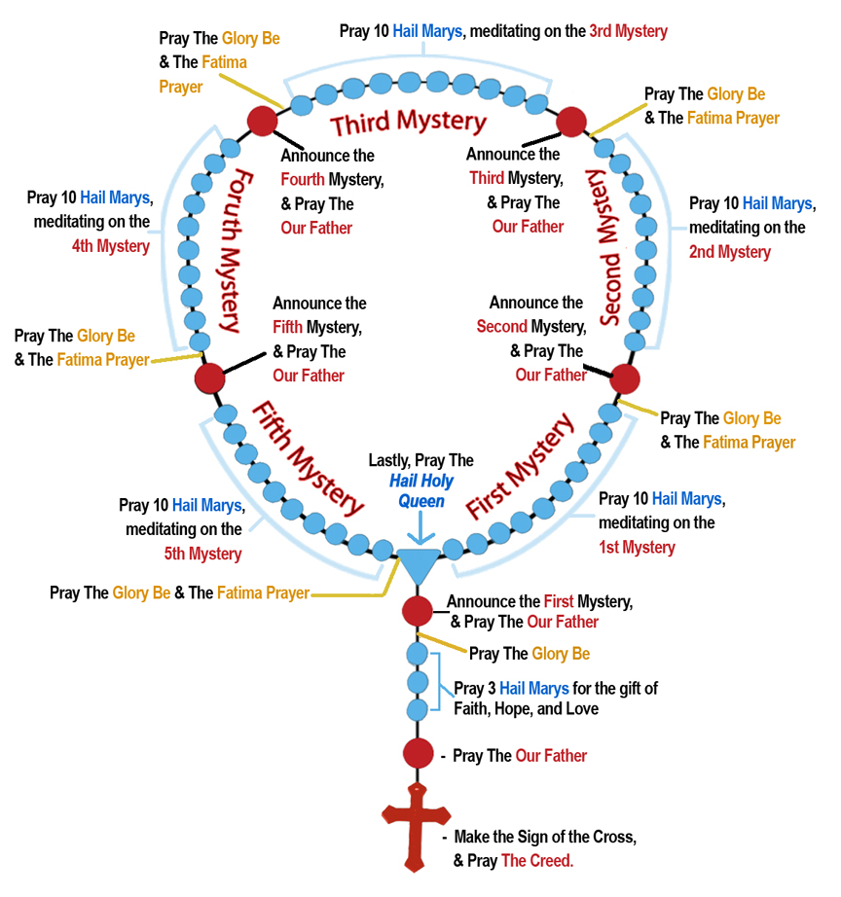

**The Five Sorrowful Mysteries (Tuesday and Friday)**

**I. The Agony in the Garden**

1. 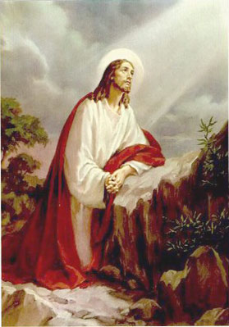After the Last Supper Jesus and the Apostles go to the Garden of Olives.
2. Jesus asks the Apostles to watch with Him.
3. Jesus withdraws and prays.
4. As He thinks of what He is to suffer and of our ingratitude, He is bathed in a sweat of blood.
5. Jesus awakens the Apostles, who have fallen asleep from weariness.
6. He returns to His prayer and asks His Father that this chalice to pass away.
7. Jesus again finds the Apostles sleeping.
8. He returns to His prayer; an Angel comes to comfort Him.
9. Mary keeps an agonizing vigil.
10. Jesus goes to meet His betrayer.

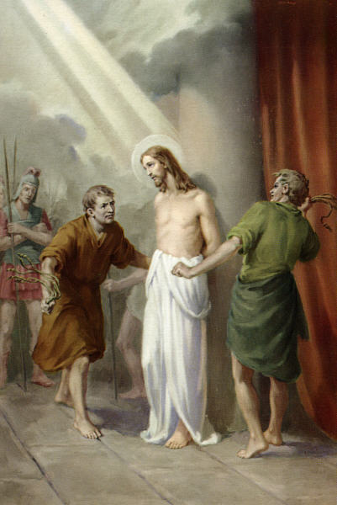  
**II. The Scourging**

1. The people cry for Christ’s crucifixion.
2. Pilate orders Jesus to be scourged even though He is innocent.
3. Jesus is stripped and bound to the pillar.
4. He is scourged by the soldiers.
5. Jesus suffers without complaint.
6. Jesus atones for our sins of the flesh.
7. Mary suffers in compassion.
8. Jesus is scourged above measure.
9. The prophecy of Isaias is fulfilled (53:5).
10. The Holy Shroud bears witness to the lashes.

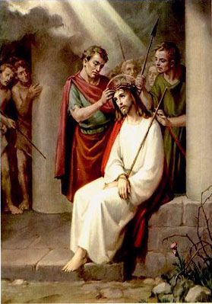**III. The Crowning with Thorns**

1. The soldiers surround Christ and mock Him.
2. Jesus is clothed in royal purple.
3. The soldiers form a crown of thorns and place it on His head.
4. They crush it down so that the thorns pierce His sacred head.
5. The soldiers place a reed in Jesus’ hand and mock Him.
6. They spit upon Him and strike His face.
7. Jesus is beaten with the reed.
8. He suffers meekly.
9. Mary suffers in compassion.
10. Pilate shows Jesus to the people: “Ecce Homo!”

**4.**

**IV. The Carrying of the Cross**

1. 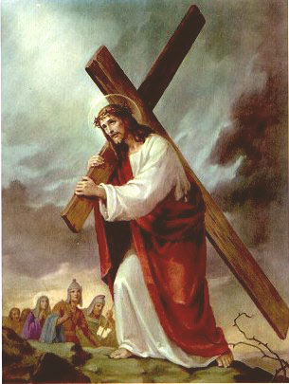Pilate, washing his hands, condemns Jesus to death.
2. The Apostles flee in fear.
3. Jesus takes up His cross.
4. He is so weak from the scourging that soon He falls beneath it.
5. The people jeer at Christ.
6. Jesus meets his afflicted Mother.
7. Simon is made to help Jesus carry the cross.
8. Veronica wipes the face of Jesus.
9. Jesus speaks to the weeping women.
10. Jesus climbs Calvary.

**V. The Crucifixion**

1. Jesus is stripped of His garments.
2. 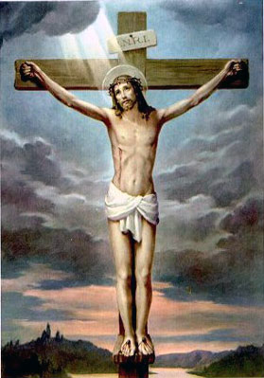He is nailed to the cross and it is raised.
3. The soldiers cast lots for Christ’s robe.
4. The people mock Jesus: “If thou art the Christ, come down from the cross!”
5. Jesus prays for His enemies: “Father, forgive them, for they know not what they do!”
6. He promises paradise to the thief.
7. He leaves us His mother: “Son, behold thy mother!”
8. Jesus gives up His spirit: “Father, into Thy hands I commend My spirit.”
9. Jesus is taken down from the cross and laid in His Mother’s arms.
10. Jesus is laid in the tomb.

**5.**

**The Five Glorious Mysteries (Wednesday, Saturday & Sunday)**

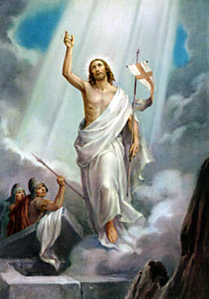**I. Resurrection**

1. Christ rises from the dead.
2. The women go to the tomb.
3. An Angel descends to roll back the stone.
4. The tomb is found empty.
5. The Angels announce the Resurrection.
6. Jesus appears to Mary Magdalen.
7. The Apostles doubt the women's word.
8. Peter and John find the cloths in the tomb.
9. Jesus joins the disciples going to Emmaus.
10. Jesus appears to the Apostles.

**II. The Ascension**

1. He shows Himself for forty days to the apostles 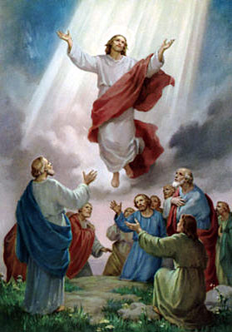and disciples, at one time to more than 500 brethren.
2. Jesus sends the Apostles to preach the Gospel.
3. He commands them not to leave Jerusalem, but to await the coming of the Holy Ghost.
4. In the presence of the apostles and disciples, a cloud receives Jesus out of their sight.
5. The Angels reassure the them and promise Christ's return.
6. Mary is filled with joy.
7. Jesus leads the Saints into Heaven.
8. Jesus sits at the right hand of the Father.
9. He intercedes for us to the Father.
10. The disciples return to the Upper Room to pray and await the Holy Ghost.

**III. The Descent of the Holy Ghost**

1. The disciples persevere in prayer with Mary.
2. 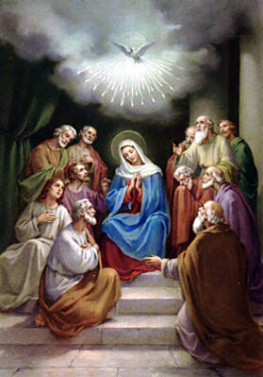Matthias is chosen to take the place of Judas.
3. The sound of a mighty wind fills the Cenacle.
4. Tongues of fire rest on the disciples.
5. The disciples are filled with the Holy Spirit.
6. The Apostles preach to the people about Christ.
7. The people are filled with wonder because each hears the Apostles speaking in his own tongue.
8. Peter preaches that Christ is the Messiah and that He rose from the dead.
9. About three thousand souls accepted the Apostles' word and were baptized that day.
10. Through the Apostles we receive the Holy Ghost.

**6.**

**III. The Birth of Our Lord**

1. 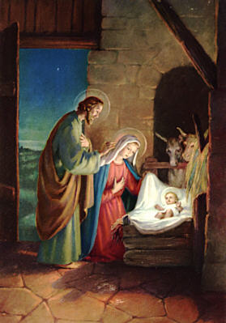Mary and Joseph journey to Bethlehem.
2. They are turned away from the inn; there is no room for them.
3. Joseph finds shelter in a stable.
4. Jesus is born and laid in a manger.
5. The angels announce the birth of Christ to the shepherds.
6. The heavenly host praises God: “Glory to God in the highest...”
7. The shepherds come to worship at the crib.
8. They marvel at the word of the angels.
9. Mary ponders these things in her heart.
10. The Magi come to adore the Christ Child.

**IV. The Presentation of Our Lord**

1. 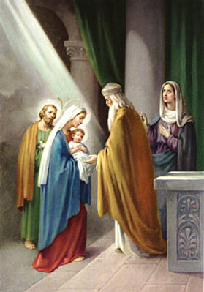Mary and Joseph bring the Infant to the Temple.
2. Mary and Joseph make an offering of two doves for the Child.
3. Simeon sees the Christ Child and recognizes the Messiah.
4. He receives the Christ Child into his arms.
5. Simeon blesses Mary and Joseph.
6. He foretells the destiny of the Child and the sorrows of His Mother.
7. Anna, who leads a life of prayer and penance, also recognizes the Savior.
8. She speaks of the child to the people.
9. An angel warns the Holy Family to flee into Egypt to escape Herod.
10. The Holy Family returns to Nazareth

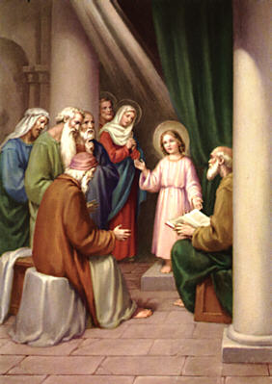

**V. The Finding of Our Lord in the Temple**

1. The Holy Family journeys to Jerusalem to celebrate the Pasch.
2. The Holy Family worships at the feast.
3. Mary and Joseph leave Jerusalem, not knowing that Jesus remained behind.
4. Jesus is found missing from the caravan after a day’s journey.
5. Mary and Joseph search for three days.
6. Jesus is found in the Temple in the midst of the doctors.
7. Mary receives her Child in Joy and anguish.
8. Jesus speaks of his Father’s work.
9. Jesus returns with Mary and Joseph; Mary ponders in her heart.
10. Jesus grew in wisdom and grace. **3.**